6
Large-Scale JavaScript Application Architecture

Any experienced programmer works hard to make the code reusable and maintainable. Here we are guided by principles of object oriented programming such as encapsulation, abstraction, inheritance, composition and polymorphism. In addition to this fundamentals we follow the “five basic principles” of object-oriented programming and design defined by Robert C. Martin and known under acronym SOLID (https://en.wikipedia.org/wiki/SOLID_(object-oriented_design)). When during code review we run into a violation of any of these principles it’s considered as a “code smell” and results in refactoring. In the core of the tasks that we solve everyday in development often lay the common problems that we meet again and again. In this chapter we will cover the most common universal architectural solutions and concepts in JavaScript development:

- Design patterns in JavaScript
- Understanding concern separation in JavaScript
- Using JavaScript MV* Frameworks

Design patterns in JavaScript
Abstract bulletproof solutions are long known and usually referred as Design Patterns. Original 23 Design Patterns in programming were firstly collected in “Design Patterns: Elements of Reusable Object-Oriented Software”, an influential book published in 1995 by Erich Gamma, Richard Helm, Ralph Johnson, and John Vlissides (GoF). These patterns are language-agnostic. Nonetheless Addy Osmani in his online book “Learning JavaScript Design Patterns” (http://addyosmani.com/resources/essentialjsdesignpatterns/book/) shows how some of the GoF’s patterns can be implemented particularly in JavaScript. Here we won’t repeat his work, instead we’ll examine how we can combine the patterns. One of common problems in JavaScript development is communication between dynamically created objects. For an instance, we have an object foo and need to call from it a method (baz) of object bar. However we cannot know if bar is already available. GoF's pattern mediator encourages us to dedicate an object, that is used to proxy communications between other objects. Thus we promote loose coupling by keeping object from direct interaction. In our case, despite of calling bar.baz we inform the mediator about our intend. The mediator will do the call when bar is available:

"use strict";

class EventEmitter {
/** Initialize */
constructor() {
/**
* @access private
* @type {EventHandler[]}
*/
this.handlers = [];
}
/**
* Subscribe a cb handler for a given event in the object scope
* @param {String} ev
* @param {Function} cb
* @param {Object} [context]
* @returns {EventEmitter}
*/
on( ev, cb, context ){
this.handlers.push({
event: ev,
callback: cb,
context: context
});
return this;
}
/**
* Emit a given event in the object
* @param {String} ev
* @param {...*} [arg]
* @returns {EventEmitter}
*/
trigger( ev, ...args ) {
this.handlers.forEach(function( evObj ){
if ( evObj.event !== ev || !evObj.callback.apply ) {
return;
}
evObj.callback.apply( evObj.context || this, args );
}, this );
return this;
}
}

window.mediator = new EventEmitter();

Here used ES6 syntax, which serves just perfectly to describe code design. With ES6 the intend can be shown concise and plain, while in JavaScript edition ES5 and older we need additionally lines and lines of code to achieve the same result.
In the example above we create mediator object by instantiating EventEmitter class. EventEmitter implements a messaging pattern known as PubSub. The pattern describes a message exchange where one object sends an event addressed to another object and the second object calls handlers if any subscribed for the event. In other words, if we subscribe a handler function of object foo for mediator event `myevent` (mediator.on), we can then invoke the handler of foo from any other object by publishing event `myevent` on the mediator (mediator.trigger)

. Let's make an example. Our imaginary application is localized. It starts with login screen. When users signs in it jumps to the dashboard with the news. User may change the language as on any of the screens. However on the first stage news view object isn't yet even created while on the second stage the login view object already destroyed. But if we use the mediator we can trigger “translate” event and all the available subscribers will receive the message:

class News {
/** Initialize */
constructor(){
mediator.on( "translate", this.update, this );
}
/** @param {String} lang */
update( lang ){
// fetch news from remote host for a given lang
console.log( "News loaded for", lang );
}
}

class Language {
/** @param {String} lang */
change( lang ) {
mediator.trigger( "translate", lang );
}
}

let language = new Language();
new News()
language.change( "de" );

Whenever user changes the language (language.change) the corresponding event is broadcasted through the mediator. When News instance is available it calls update method, that receives event payload. In a real application it would load news for the given language and update the view.

So what did we achieve? When using mediator and event-driven approach (PubSub) our objects/modules are loosely coupled and therefore the overall architecture better accepts requirements changes. Besides we gain more flexibility in unit-testing.
At the time this book is written no browser provides native support for ES6 class statement. However you can run the given code using Babel.js run-time https://babeljs.io/docs/usage/browser/ or transpiring.
When the application grows and we are getting too many events circulating, it makes sense to encapsulate events handling into a separate message hub object. Here comes in mind the facade pattern, which defines a unified high-level interface for other interfaces:

class Facade {
constructor(){
mediator.on( "show-dashboard", function(){
this.dashboard.show()
this.userPanel.remove();
}, this )
.on( "show-userpanel", function(a){
this.dashboard.hide()
this.userPanel = new UserPanel( this.user );
}, this )
.on( "authorized", function( user ){
this.user = user;
this.topBar = new TopBar( user.name );
this.dashboard = new Dashboard( user.lang );
this.mainMenu = new MainMenu( user.lang );
}, this )
.on( "logout", function(){
this.userPanel.remove();
this.topBar.remove();
this.dashboard.remove();
this.mainMenu.remove();
this.login = new Login();
}, this );
}
}

After initializing Facade class we can trigger a complex flow where multiple modules involved by simply firing an event on the mediator. This way we encapsulate behavioral logic into a dedicated object, what makes the code more readable and the whole system easier to maintain.

Understanding concern separation in JavaScript
While writing JavaScript (especially client-side) one of the major challenges is to avoid “spaghetti code”, whereas the same module renders the user view, handles user interactions and does the business logic. Such module may quickly grow into a monster of a source file where developer rather gets lost than spots and resolves a problem.

MVC

Programming paradigm known as MVC (Model View Controller) splits the application functionality into separate layers such as presentation, data and user-input. MVC in a nutshell implies that user interactions with the view land in a controller module, that manipulates with a model, which updates the view. In JavaScript the controller is usually an observer that listens to UI events. User clicks a button, the event is fired, the controller addresses the corresponding model. For example, the controller requests the model to send submitted data to the server. The view gets notified about model state change and reacts accordingly, let’s say displays message “Data saved”.

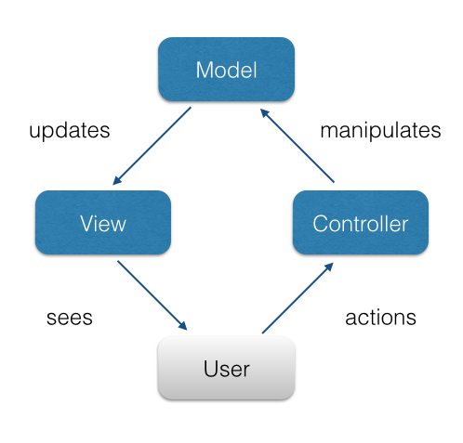
Insert image B04886_06_01.png

As you see, we can keep all the user-input handlers encapsulated in a single module (here the Controller), We can abstract data layer following Domain-Driven design practices into model module. Eventually we have a view module responsible for updating UI. So, the model has no knowledge about the component’s presentation (HTML, CSS), nothing about DOM events - that’s just pure data and operations on it. The controller knows only events from the view and the view API. At last, the view knows nothing about model and controller, but exposes its API and sends events. Thus we have an efficient architecture, that is easy to maintain and test.
However, in case of JavaScript-built UI it’s not that easy to draw a line between the view logic and controller one. Here get handy MVC derivatives: MVP and MVVM.

MVP
The “P” in MVP stands for presenter that serves user requests. The presenter listens to the view events, retrieves data, manipulates it and updates the presentation by using view API. The presenter can interact with models to persist data. As you see the presenter acts like a manager that receives a request, processes it by using available resources and directs the view to change.

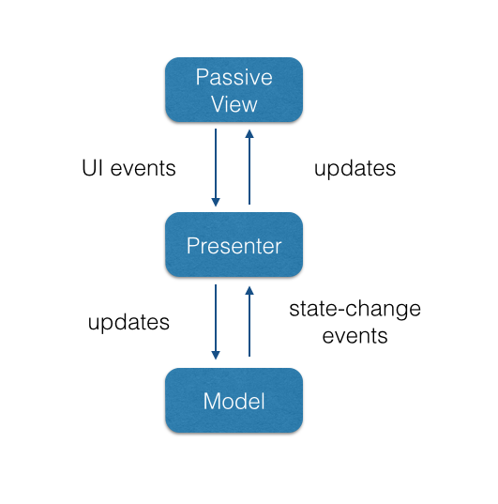
Insert image_B04886_06_02.png
MVP provides better testability and concern separation comparing to MVC. You can find an example of TODO application implementing MVP at http://codepen.io/dsheiko/pen/WQymbG

MVVM
Passive view as of MVP is mostly about data bindings and proxing UI events. In fact that's something we can abstract. The view in MVVM (Model View ViewModel) approach may not require any JavaScript at all. Usually the view is HTML extended with directives known by ViewModel. The model represents domain-specific data and exposes concomitant methods such as validation. The ViewModel is a middleman between view and model. It converts the data objects from the model for the view. For an instance, when model property contains a raw datetime, the ViewModel converts it into the form expected in the view like “1 January 2016, 00:01”.

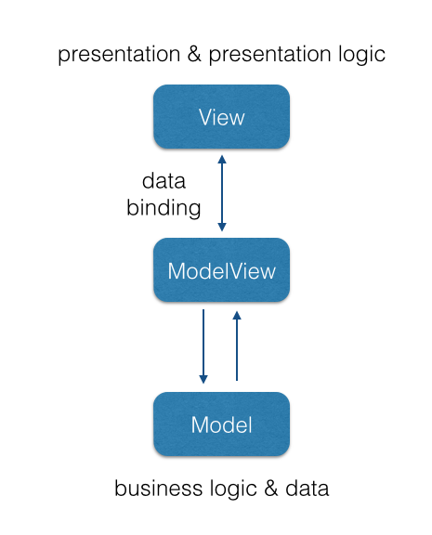
Insert image_B04886_06_03.png
The MVVM pattern makes the advantage of both imperative and declarative programming. It may drastically reduce the development time by abstracting most of generic view logic in the common binder module. The pattern gains momentum with popular JavaScript frameworks such as Knockout, Angular and Meteor. You can find an example of RSS reader application based on MVVM pattern at https://msdn.microsoft.com/en-us/magazine/hh297451.aspx

Using JavaScript MV* Frameworks
When starting a new scalable web application you have to decide either you go with a framework or not. It’s hard now to find any large projects that are not built on the top of a framework. Yet there are drawbacks in using frameworks, just take a look at Zero Framework Manifesto (http://bitworking.org/news/2014/05/zero_framework_manifesto). But if you decide in favor of frameworks then you are in a quandary about which one to pick. That’s indeed not an easy task. JavaScript frameworks today are quite numerous, just take a look at the variety available at TodoMVC http://todomvc.com. It’s hardly feasible to review all of them, but we can briefly examine a few most popular. According to recent surveys (e.g. http://ashleynolan.co.uk/blog/frontend-tooling-survey-2015-results) among most trendy are Angular, React and Backbone. All three give quite dissimilar development paradigms. So they are fitting to make an overall picture on JavaScript frameworks in general.

Backbone
Backbone (http://backbonejs.org) is a very lightweight and easy to start with. That’s the only popular framework where you can grasp the entire codebase in a considerably short time (http://backbonejs.org/docs/backbone.html). Inherently Backbone gives you a consistent abstraction and nothing besides. By and large we encapsulate all the UI-related logic into a subtype of Backbone.View. Any data required by the view we put into a derivative of Backbone.Model or Backbone.Collection (when it's a list of entries). Eventually we route hash-based navigation requests by means of Backbone.Route.
Let's consider an example. Our imaginary application allows to look up for a contact by a given email address. Since we want it user friendly the application form is expected to validate as you type in it. For that we need a little of HTML:

<form data-bind="fooForm">
<label for="email">Email:</label>
<input id="email" name="email" required />
<span class="error-msg" data-bind="errorMsg"></span>
<button data-bind="submitBtn" type="submit">Submit</button>
</form>
Here we have input control, submit button and container for a possible error message. In order to manage it we will use the following Backbone.View:
ContactSearchView.js

"use strict";
/** @class {ContactSearchView} */
var ContactSearchView = Backbone.View.extend(/** @lends ContactSearchView.prototype */{
events: {
"submit": "onSubmit"
},
/** @constructs {ContactSearchView} */
initialize: function() {
this.$email = this.$el.find( "[name=email]" );
this.$errorMsg = this.$el.find( "[data-bind=errorMsg]" );
this.$submitBtn = this.$el.find( "[data-bind=submitBtn]" );
this.bindUi();
},
/** Bind handlers */
bindUi: function(){
this.$email.on( "input", this.onChange.bind( this ) );
this.model.on( "invalid", this.onInvalid.bind( this ) );
this.model.on( "change", this.onValid.bind( this ) );
},
/** Handle input onchange event */
onChange: function(){
this.model.set({
email: this.$email.val(),
// Hack to force model running validation on repeating payloads
"model:state": ( 1 + Math.random() ) * 0x10000
}, { validate: true });
},
/** Handle model in invalid state */
onInvalid: function(){
var error = arguments[ 1 ];
this.$errorMsg.text( error );
this.$submitBtn.prop( "disabled", "disabled" );
},
/** Handle model in valid state */
onValid: function(){
this.$errorMsg.empty();
this.$submitBtn.removeProp( "disabled" );
},
/** Handle form submit */
onSubmit: function( e ){
e.preventDefault();
alert( "Looking up for " + this.model.get( "email") );
}
});
In the constructor (initialize method) we bind acting nodes of the HTML to the properties of the view and subscribe handlers to UI and model events. Namely we register listener methods on form “submit” and input “input”. The second handler invokes as we type and updates the model. The model runs validation and according to the result responds with model event “invalid” or “change”. In the case of “invalid” event the view shows up the error message, otherwise it gets hidden.
Now we can add the model:
ContactSearchModel.js
"use strict";
/** @class {ContactSearchModel} */
var ContactSearchModel = Backbone.Model.extend(/** @lends ContactSearchModel.prototype */{
/** @type {Object} */
defaults: {
email: ""
},
/**
* Validate email
* @param {String} email
*/
isEmailValid: function( email ) {
var pattern = /^[a-zA-Z0-9\!\#\$\%\&\'\*\+\-\/\=\?\^\_\`\{\|\}\~\.]+@[a-zA-Z0-9.\-]+\.[a-zA-Z]{2,4}$/g;
return email.length && pattern.test( email );
},
/**
* Validate model
* @param {Map} attrs
*/
validate: function( attrs ) {
if ( !attrs.email ) {
return "Email is required.";
}
if ( !this.isEmailValid( attrs.email ) ) {
return "Invalid email address.";
}
}
});

This model defines domain data in defaults property and provides validate method that is called automatically when we set or save the model.
Now we can combine all together and initialize the view:
<!DOCTYPE html>
<html>
<script type="text/javascript" src="//ajax.googleapis.com/ajax/libs/jquery/1.11.3/jquery.min.js"></script>
<script type="text/javascript" src="//cdnjs.cloudflare.com/ajax/libs/underscore.js/1.5.2/underscore-min.js"></script>
<script type="text/javascript" src="//cdnjs.cloudflare.com/ajax/libs/backbone.js/1.0.0/backbone-min.js"></script>
<script type="text/javascript" src="ContactSearchView.js"></script>
<script type="text/javascript" src="ContactSearchModel.js"></script>
<style>
fieldset { border: 0; }
.error-msg{ color: red; }
</style>
<body>
<form data-bind="fooForm">
<fieldset>
<label for="email">Email:</label>
<input id="email" name="email" required />
<span class="error-msg" data-bind="errorMsg"></span>
</fieldset>
<fieldset>
<button data-bind="submitBtn" type="submit">Submit</button>
</fieldset>
</form>
<script>

// Render foo view
new ContactSearchView({
el: $( "[data-bind=fooForm]" ),
model: new ContactSearchModel
});

</script>
</body>
</html>

Backbone itself is surprisingly small in size (6.5K gzipped), but with the dependencies jQuery and Underscore makes quite a bundle. Both dependencies were vital in the past, but now that’s under the question do we need them at all. So it makes sense to check Exoskeleton (http://exosjs.com/) project, that is an optimized version of Backbone that works perfectly without the dependencies.

Angular
Angular (http://Angular.org) seems now as the most popular JavaScript framework in the world. It is supported by Google and considered as a framework that solves most of routine tasks for you. In particular Angular has a feature called two-way binding, meaning that UI changes propagate to the bound model and, vise versa, model changes (e.g. by XHR) update the UI.
In AngularJS we define behavior straight in HTML with directives. Directives are custom elements and attributes that assume UI logic just like web-components. Actually you can create functional widgets in AngularJS without writing a single line of JavaScript code. Models in AngularJS are simple data containers and unlike Backbone have no connection to external sources. When we need to read or write data we use services. When any data sent to View, we can use filters to format the output. The framework leverages across the whole its architecture dependency injection (DI) pattern, what makes the modules easier to meet requirement changes and unit-test. Let’s see it in practice:

<!DOCTYPE html>
<html>
<script src="http://ajax.googleapis.com/ajax/libs/Angular/1.3.14/angular.min.js"></script>
<style>
fieldset { border: 0; }
.error-msg{ color: red; }
</style>
<body>
<form ng-app="contactSearch" name="csForm" ng-submit="submit()" ng-controller="csController">
<fieldset>
<label for="email">Email:</label>
<input id="email" name="email" ng-model="email" required
ng-pattern="/^[a-zA-Z0-9\!\#\$\%\&\'\*\+\-\/\=\?\^\_\`\{\|\}\~\.]+@[a-zA-Z0-9.\-]+\.[a-zA-Z]{2,4}$/" />
<span class="error-msg" ng-show="csForm.email.$dirty && csForm.email.$invalid">
<span ng-show="csForm.email.$error.required">Email is required.</span>
<span ng-show="csForm.email.$error.pattern">Invalid email address.</span>
</span>
</fieldset>
<fieldset>
<button type="submit" ng-disabled="csForm.email.$dirty && csForm.email.$invalid">Submit</button>
</fieldset>
</form>
<script>
"use strict";
angular.module( "contactSearch", [] ).controller( "csController", [ "$scope", function ( $scope ){
$scope.email = "";
$scope.submit = function() {
alert( "Looking up for " + $scope.email );
};
}]);
</script>
</body>
</html>

In this example we declare input field and bind it to model email (ng-model directive). Form validation works in the very way it happens in HTML5 Forms: if we declare input type email and it gets validated accordingly. Here we go with default text type and use ng-pattern (similar to HTML5 pattern) attribute to set the same validation rules for email as in the Backbone case. Further we rely on ng-show directive to display error messages block when input state is empty (csForm.email.$dirty) or invalid (csForm.email.$invalid). In this case the submit button on the contrary hides. Using directives ng-controller and ng-submit we bind controller csController and on-submit handler to the form. In the body of csController (JavaScript) $scope.submit expects handler function for form submit event.

As you can see going Angular it takes much less code in total to implement the same task. However, one should accept that keeping application logic in HTML makes it really hard to read.
Furthermore, Angular subscribes many watchers per a directive (intended handlers, automatic Dirty Checking and so on) and makes it on pages with numerous interactive elements slow and resource-expensive. If you want to tune your application performance, you rather to learn Angular source code and it’ll be a challenging task with ~11.2K lines of code (ver. 1.4.6)

React
React (https://facebook.github.io) is a project of Facebook, that isn’t really a framework, but rather a library. The unique approach of React implies a component-based application. Inherently React defines Views of the components utilizing so-called Virtual DOM, what makes UI rendering and updating startling fast. With this focus on the View, React comprises a template-engine. Optionally React components can be written in a subset of JavaScript called JSX where you can put HTML templates within JavaScript. JSX can be parsed dynamically like in the example below or precompiled. Since React deals with the View only and makes no assumptions about other concerns, it makes sense to use in conjunction with other frameworks. Thus React can be plugged into a framework (e.g. as directives in Angular or Views in Backbone).
While implementing the contact search application this time

we use React to control the view of our example splitting it into two components (FormView and EmailView). The first one defines the view for the search form:

/** @class {FormView} */
var FormView = React.createClass({
/** Create an initial state with the model */
getInitialState: function () {
return {
email: new EmailModel()
};
},
/**
* Update state on input change event
* @param {String} value - changed value of the input
*/
onChange: function( value ){
this.state.email.set( "email", value );
this.forceUpdate();
},
/** Handle form submit */
onSubmit: function( e ){
e.preventDefault();
alert( "Looking up for " + this.state.email.get( "email") );
},
/** Render form */
render: function () {
return <form onSubmit={this.onSubmit}>
<fieldset>
<label htmlFor="email">Email:</label>
<EmailView model={this.state.email} onChange={this.onChange} />
</fieldset>
<fieldset>
<button data-bind="submitBtn" type="submit">Submit</button>
</fieldset>
</form>;
}
});
In render method we declare the view of the component using JSX notation. That makes it much easier to manipulate the Virtual DOM. Similarly to Angular we can address the component scope directly in the HTML. Thus we subscribe to form submit event and to input change event by referring in attributes onSubmit and onChange to the corresponding handlers. Since React provide no built-in model we reuse ContactSearchModel, the model we created while exploring Backbone.
You might notice a custom tag EmailView in the JSX. That is how we refer to our second component, which represents email input control:
/** @class {EmailView} */
var EmailView = React.createClass({
/**
* Delegate input on-changed event to the from view
* @param {Event} e
*/
onChanged: function( e ){
this.props.onChange( e.target.value );
},
/** Render input */
render: function () {
var model = this.props.model;
return <span>
<input id="email" type="text" value={model.email} onChange={this.onChanged} />
<span className="error-msg" data-bind="errorMsg">
{model.isValid() ? "" : model.validationError}</span>
</span>;
}
});

Here we bind the email input to the model and error message container to the model state. We also pass input onChange event to the parent component.
Well, now we can add the components in the HTML and render the form:

<!DOCTYPE html>
<html>
<head>
<script src="https://cdnjs.cloudflare.com/ajax/libs/react/0.13.3/react.js"></script>
<script src="https://cdnjs.cloudflare.com/ajax/libs/react/0.13.3/JSXTransformer.js"></script>
<script type="text/javascript" src="//cdnjs.cloudflare.com/ajax/libs/underscore.js/1.5.2/underscore-min.js"></script>
<script type="text/javascript" src="//cdnjs.cloudflare.com/ajax/libs/backbone.js/1.0.0/backbone-min.js"></script>
<script type="text/javascript" src="ContactSearchModel.js"></script>
<style>
fieldset { border: 0; }
.error-msg{ color: red; }
</style>
</head>
<body>
<div data-bind="app"></div>
<script type="text/jsx">
/** @jsx React.DOM */

// Please insert here both components
// FormView and EmailView

// render app
React.render(
<FormView />,
document.querySelector( "[data-bind=app]" )
);
</script>
</body>
</html>

We address components in the templates like web-components by the corresponding custom elements. Do not confuse yourself over the similarity, React components are abstracted from browser while web-components go like browser-native things. The core concept of React, the Virtual DOM allows to avoid unnecessary DOM reflow cycles what makes the library preferable for high-performance applications. React is real good for rendering static pages on the server using Node.js. Thus we can reuse application components between server and client sides.

Summary
Writing maintainable code is an art. Probably the best book guiding on it is “Clean Code: A Handbook of Agile Software Craftsmanship” by Robert C. Martin. It’s about naming functions, methods, classes, commenting, code formatting and of course about correct use of OOP and SOLID. However when reusing solutions described in this book, or in any of Design Patterns series we have to translate them into JavaScript and it can be challenging due to the nature of the language. On higher level we have to split the code into layers such as presentation, business logic, data access, persistence where each bundle of code addresses the only concern and loosely coupled with others. Here we may choose an approach to go with. In JavaScript world it’s usually a derivative of MVC (MVP or MVVM or other). Considering the said above, a decent programming design requires a lot of abstraction. Today we can use one numerous frameworks. They provide diverse programming paradigms.

